
GIS Library Tutorials – Introduction to ArcGIS Online – 6

Creating Point Features

This allows you to place some points of interest on the map. You can use this method if you don’t have a spreadsheet or file with data.

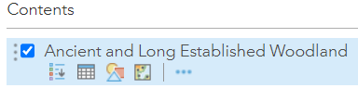
Hide the labels which are displayed on the map. Hover over the Ancient and Long Established Woodland layer name. Left click on the 3 horizontal blue dots.

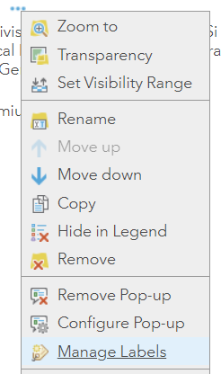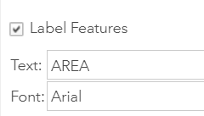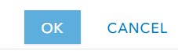
Left click on Manage Labels

Left click in the Label Features checkbox to remove the tick, and so make the labels invisible

Left click on OK

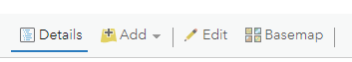
Left click on Details

Left click on the Add button

Left click on Add Map Notes

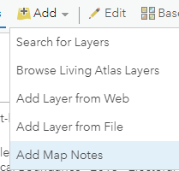

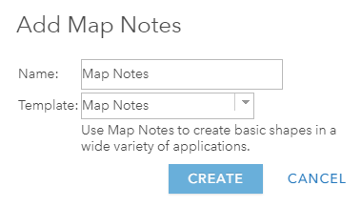
This opens a new window, where the project can be named.

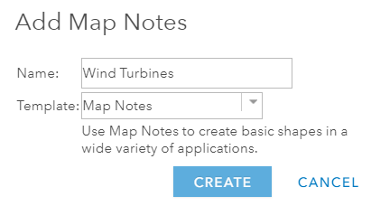
Type in Wind Turbines for the name of your project.
Leave the default Template Map Notes as it is.

Left click on Create

It doesn’t have to be a structure that you are adding. It could be a species of animal or plant.
Or it could be sites of traffic accidents / outbreaks of measles / level of pollution, etc

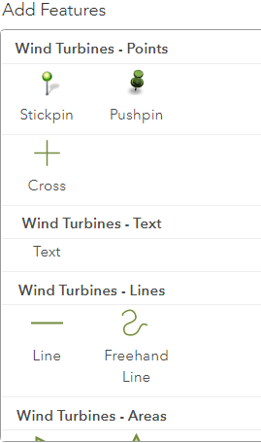
We will now create Points using the Stickpin feature to represent locations of Wind Turbines.

Left click on the Stickpin symbol
The contents pane of your map will now change to Edit and it has options to create 4 feature types: Points, Text, Lines, Areas

A textbox will appear – so move this around the map and choose a location where there is some woodland within sight

- then left click on the map with your mouse to create the point

In the Points box which opens change the Title from Point to Wind Turbine One

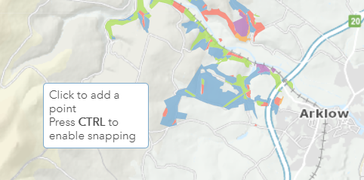

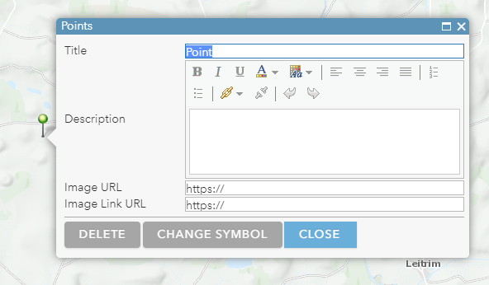

Copy and paste this text into the Description box

A wind turbine is a device that converts the kinetic energy of wind into electrical energy. Wind turbines are an increasingly important source of intermittent renewable energy, and are used in many countries to lower energy costs and reduce reliance on fossil fuels.

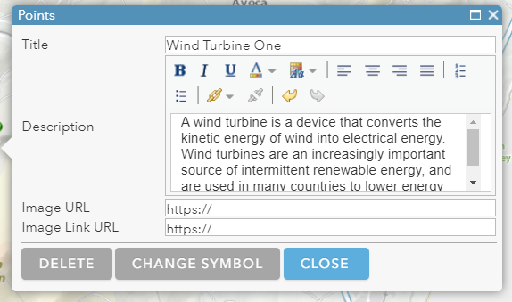

Here is the link for the Image URL (use this to add an image to the map)

https://upload.wikimedia.org/wikipedia/commons/d/d5/Wind_Turbine_%28184178167%29.jpeg

Image URLs will show a thumbnail picture on your map. You must link to a jpeg or png which has a https link (in other words a jpeg or png that is on a website or blog). If you have your own image then you could upload it to flickr or Imgur - then it will have a URL which can be linked to.

Here is the link for the Image Link URL

https://en.wikipedia.org/wiki/Wind_turbine

With Image Link URL you can click on your photo / image and link out to another website page.

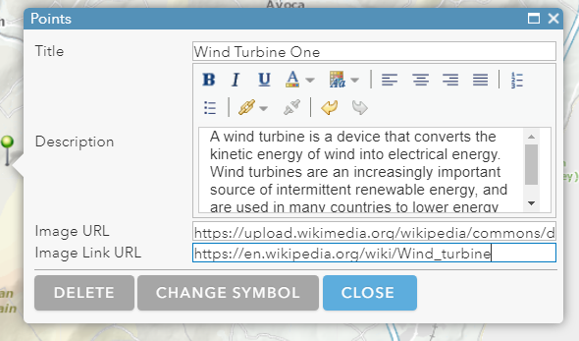
When you have pasted in the
URLs
left click on the CLOSE button

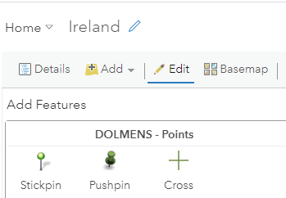
In the Contents Pane the Edit tab is still selected, so left click on the Details tab – this will allow you view your new Point on the map

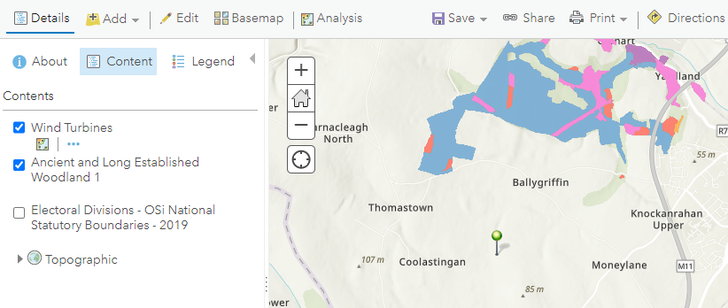

Left click on the Stickpin to read the details and view your image

As you have included an Image Link URL you can left click on the photo to open the Wikipedia page

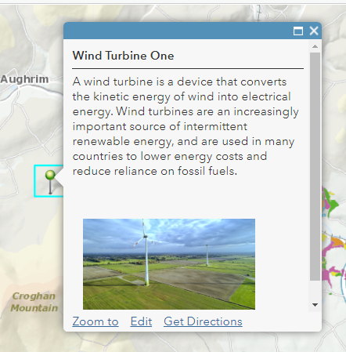

To add another point, left click on Edit
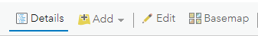

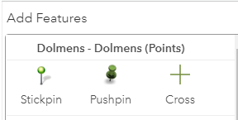
Left click on the Stickpin icon

On the map left click with the mouse to place this Stickpin icon
This opens the box where you add information about your Point

In the Title box change ‘Point’ to Wind Turbine Two

Add some text into the Description section – e.g., This is the 2nd wind turbine to show on my map
you can use formatting such as Bold

Left click on Change Symbol

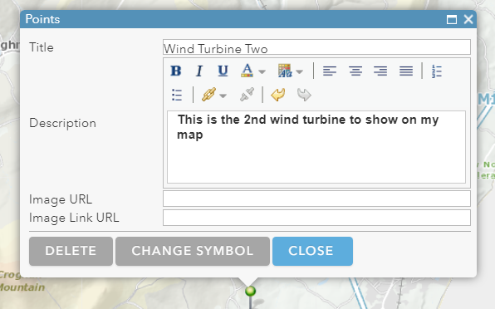

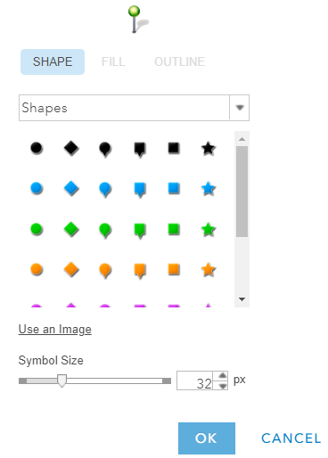
Left click on the pull-down menu at Shapes

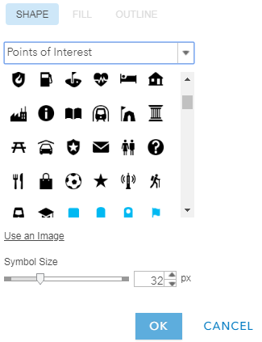
This opens a range of categories to choose from, e.g., Points of Interest

Left click on the symbol you want to use

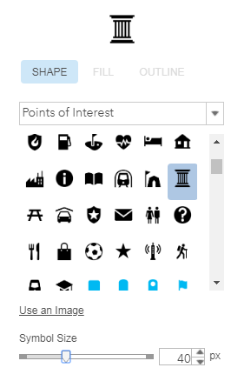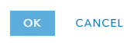
Left click on the tab on the slider and move it along the slider to increase or decrease the size of your symbol

Left click on OK

The selected symbol is now shown on the map
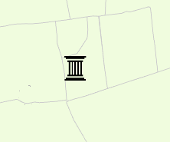

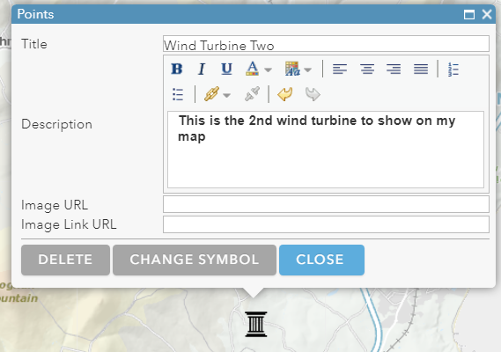
On the Points box left click on Close

Add some text next to your Point

Firstly, left click on the Details tab 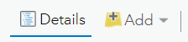

Left click on the icon on the map. In the information box left click on Edit

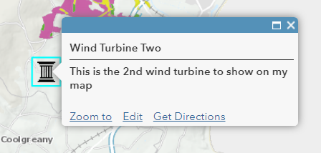

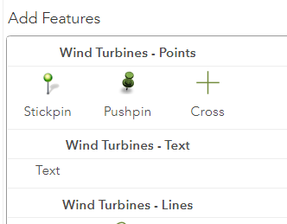
This opens the panel on the left-hand side

Left click on the word Text

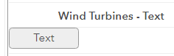
The background on the word Text changes to grey

Move your mouse pointer to see a text box appear, and move it next to your Point

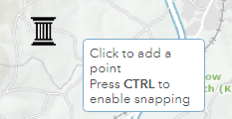

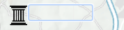
Left click beside your Point to add your text label

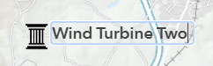
Left click into the box and type the text you want shown next to your icon

To make style changes to this text label left click just below the text – a box with dashed lines and handles will appear. By left clicking on a handle and dragging you can increase text size, or you can swivel / stretch the direction of the text.

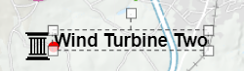

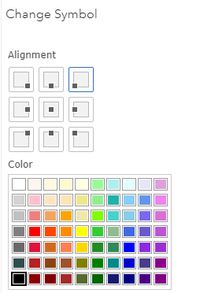
In the panel on the left, options for changing the text label will appear

Left click on any Alignment option to change the placement of the text

Left click on one of the colours to change the colour of the text – make sure it is not too similar to your background map

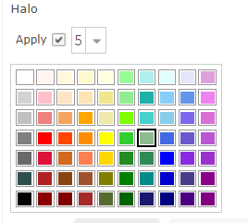
To add a halo of colour around your text, left click in the Apply checkbox, then left click on a number – a higher number gives a wider halo

Left click on the colour of your choice
These style changes will take immediate effect on the text

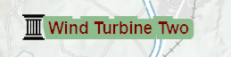

To remove a label, you can either left click on UNDO
at the bottom of the menu on the left side 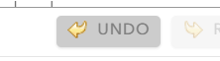

Or if you have already saved the map and want to remove the label, left click on the Edit tab, left click within the label and select the text, press the backspace key on your keyboard, then left click anywhere on your map

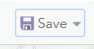
Save your map again

